CSS corp interview:

1.How will u recover lost pemkey?

2. How will u attach s3 bucker to ec2 instances?

3.How will u attach storage when storage is filled?

4. What are the storage types in Kubernetes?

5.What are the network types in Kubernetes?

6. How will u connect to ec2 when ssh is disabled? Or what are the ways to connect to ec2 when ssh is disabled?

7.What is the port No for sqldb?

8. What is the port No for postgresdb?

9.Tell me about the Kubernetes architecture?

10. How will u expose the internet to docker application?

11.How do you handle build failures and troubleshoot issues in your build and release process?

12.What is the command to see all running & stopped containers in docker?

13.What is the use of systems manager in AWs?

1.How will u recover lost pemkey?

Create backup of ami for existing server & by using of ami create new instance with new keypair

Bcz if u lost key pair we cannot recover

Ref1

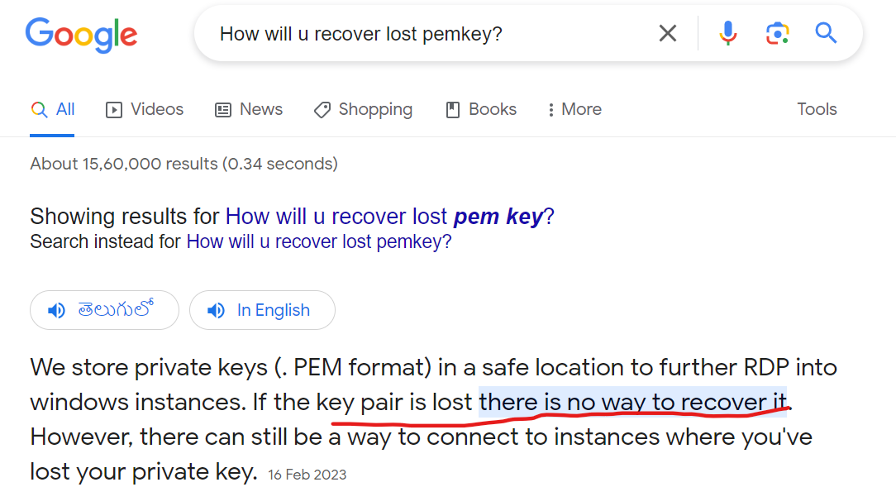

<https://www.linkedin.com/pulse/how-do-i-recover-windows-ec2-instance-pem-file-lost-cloud-in/>

2. . How will u attach s3 bucker to ec2 instances?

Ref1 iam role(public acces)

1.create iam s3 fulll access role

2,then attach iam role to ec2 server

3.install aws cli in linux server & then use coommad aws s3 ls

Get list of all the buckets

Ref2

Iam user (access key &secret key)

1.use this command aws configure in linux server

Provide region

Access

Secret key

Format =json or yaml

2.install aws cli in linux server & then use coommad aws s3 ls

Get list of all the buckets

Private access( ec2 to s3)

Use for the s3 endpoint gateway & it is direct connection nat server to s3 &It is reduce nat charges & check below link

<https://www.youtube.com/watch?v=CIME4XLVIyU&t=4s>

3.How will u attach storage when storage is filled?

we have three type of storages in aws

s3

iam role attach to server

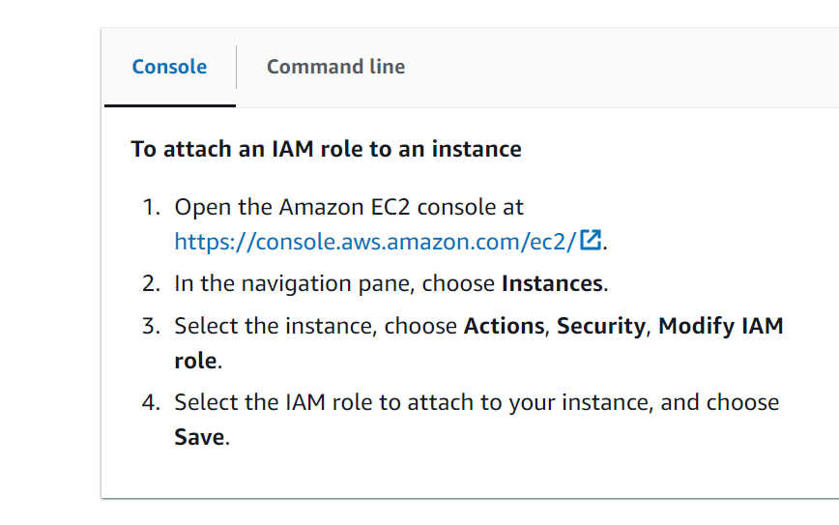

ebs

<https://www.youtube.com/watch?v=6OY4wVVv9Ew>

efs

<https://docs.aws.amazon.com/efs/latest/ug/wt1-test.html>

<https://www.google.com/search?q=efs+mount+on+ec2&sca_esv=597969321&rlz=1C1GCEA_enIN1071IN1071&tbm=vid&sxsrf=ACQVn0-s8unTRL0mqBSAN4rtUfZha4N24w:1705106695824&source=lnms&sa=X&ved=2ahUKEwiDoqK3kdmDAxWuSWwGHeoRCP4Q_AUoAnoECAEQBA&biw=1280&bih=585&dpr=1.5#fpstate=ive&vld=cid:2a415046,vid:Aux37Nwe5nc,st:0>

elastic file system it is centralized file system &

example: master slave configuration of Jenkins server


        Diagram showing three Availability Zones in a VPC, containing EC2 instances and
          mount targets, and a mounted EFS regional file system.
      

What are the storage types in Kubernetes?

<https://kubernetes.io/docs/concepts/storage/storage-classes/>

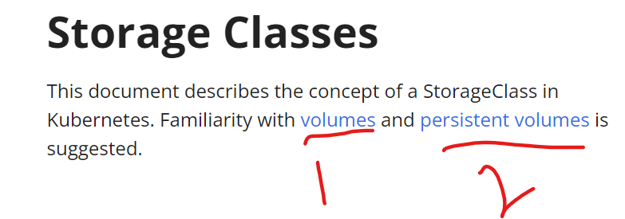

<https://kubernetes.io/docs/concepts/storage/volumes/>

Empty dir

Pv

Pvc

Secret

Config map

For a Pod that defines an emptyDir volume, the volume is created when the Pod is assigned to a node. As the name says, the emptyDir volume is initially empty. All containers in the Pod can read and write the same files in the emptyDir volume, though that volume can be mounted at the same or different paths in each container. When a Pod is removed from a node for any reason, the data in the emptyDir is deleted permanently.

A Kubernetes emptyDir volume is a directory that exists on the local node's filesystem with no contents. These volumes are stored either on the node's backing disk storage or memory. This type of volume is typically used as a local cache or a means to share data between different containers of a POD

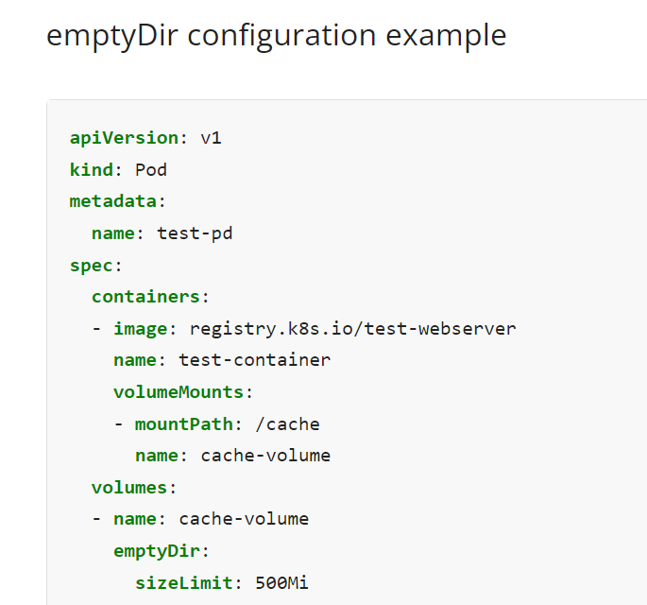

<https://kubernetes.io/docs/concepts/storage/persistent-volumes/>

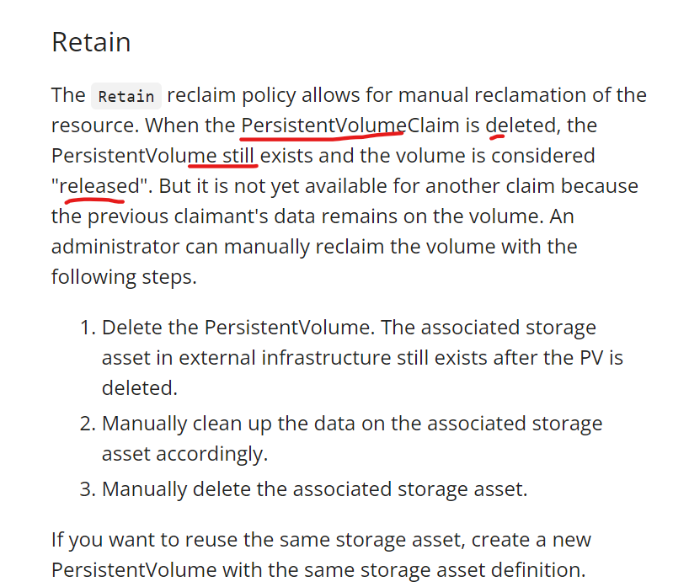

Secret

<https://kubernetes.io/docs/concepts/configuration/secret/> 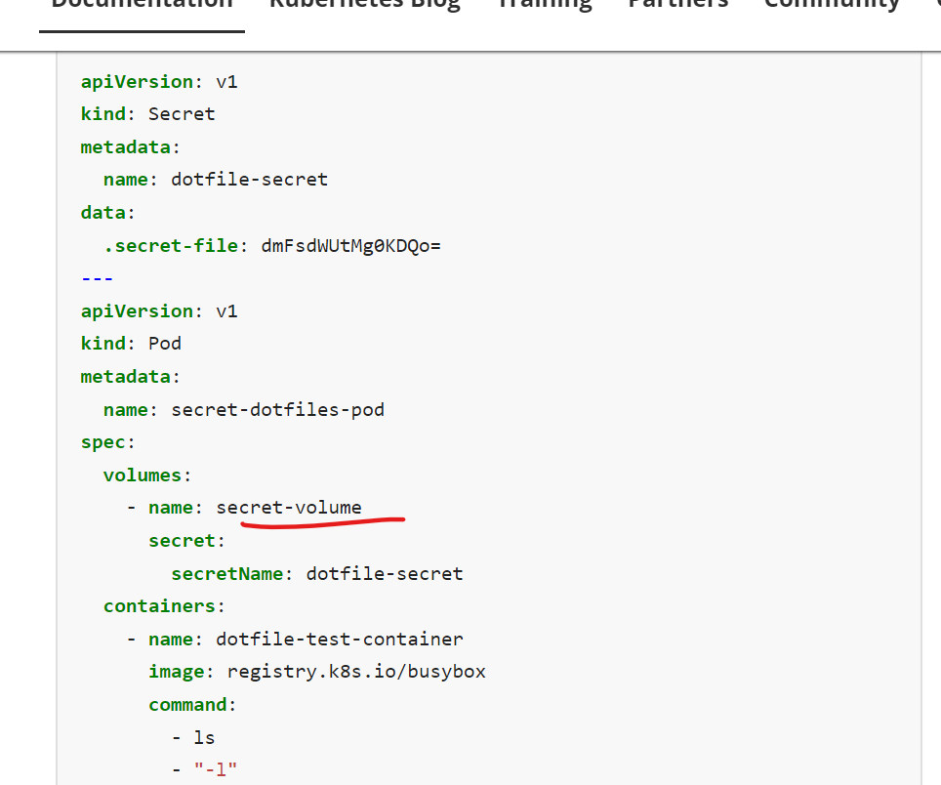

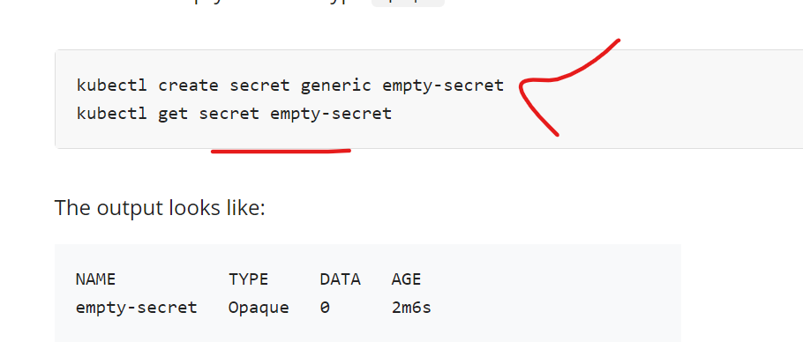

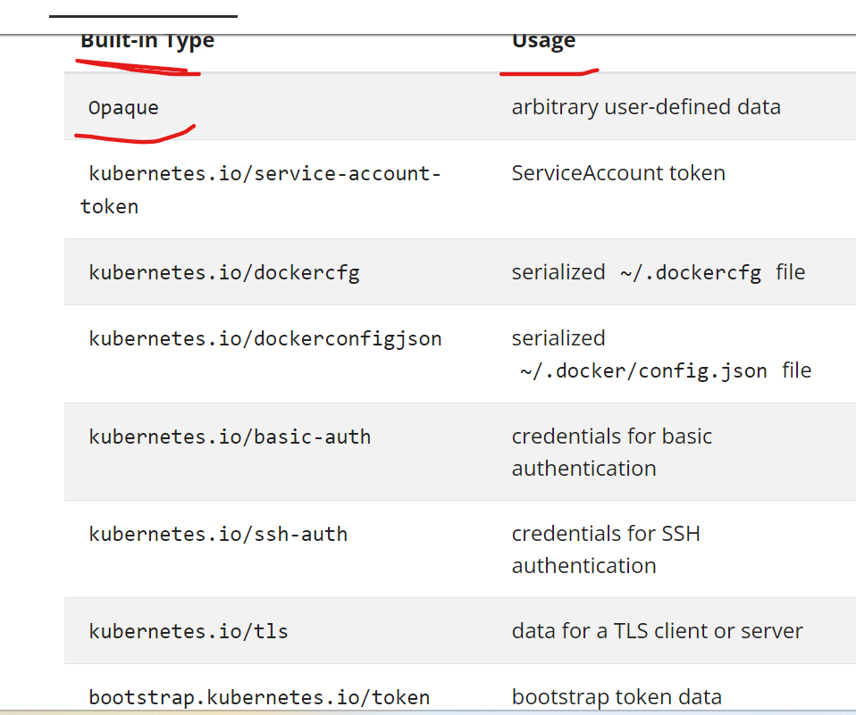

Configmap:

https://kubernetes.io/docs/concepts/configuration/configmap/

There are four different ways that you can use a ConfigMap to configure a container inside a Pod:

1. Inside a container command and args
2. Environment variables for a container
3. Add a file in read-only volume, for the application to read
4. Write code to run inside the Pod that uses the Kubernetes API to read a ConfigMap

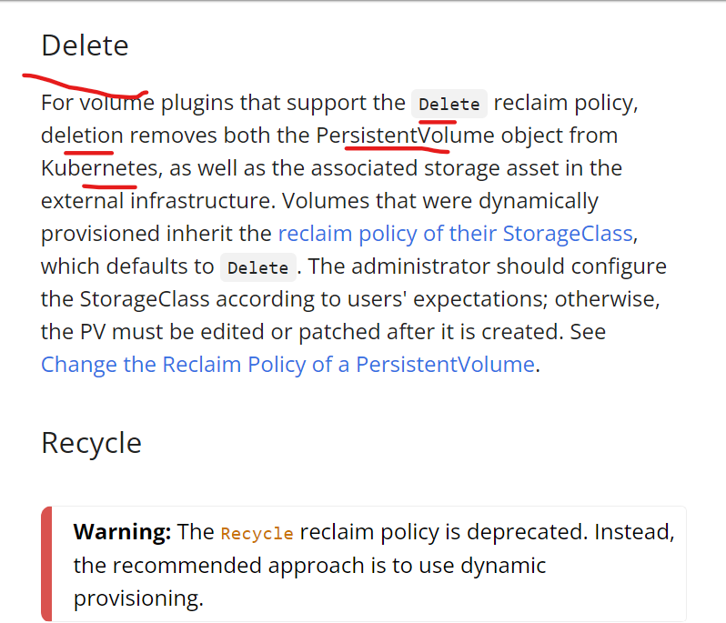

5.What are the network types in Kubernetes?

Pod to pod

* The network plugin is configured to assign IP addresses to Pods.
* The kube-apiserver is configured to assign IP addresses to Services.
* The kubelet or the cloud-controller-manager is configured to assign IP addresses to Nodes.

Wt is n/w plugin

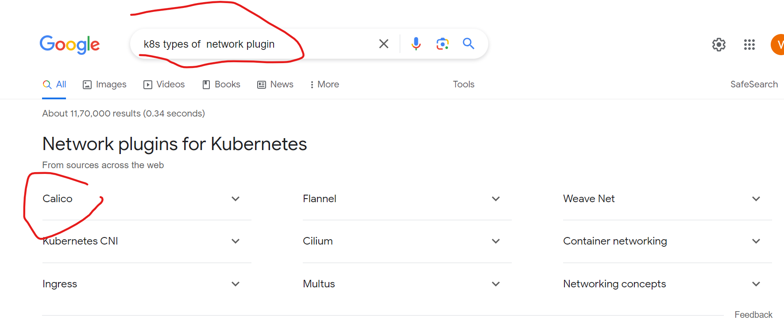

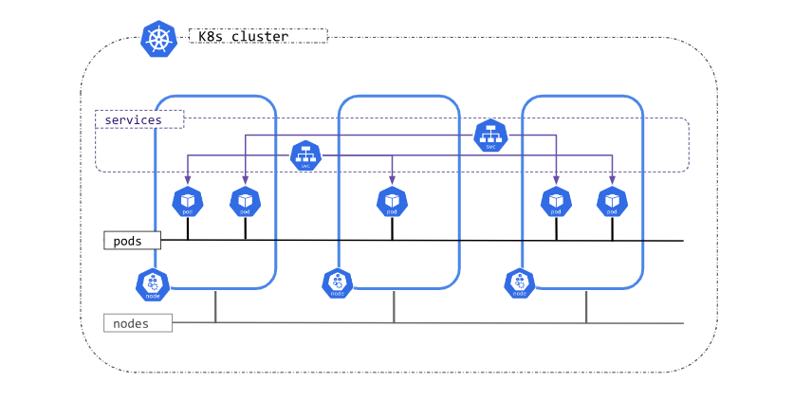

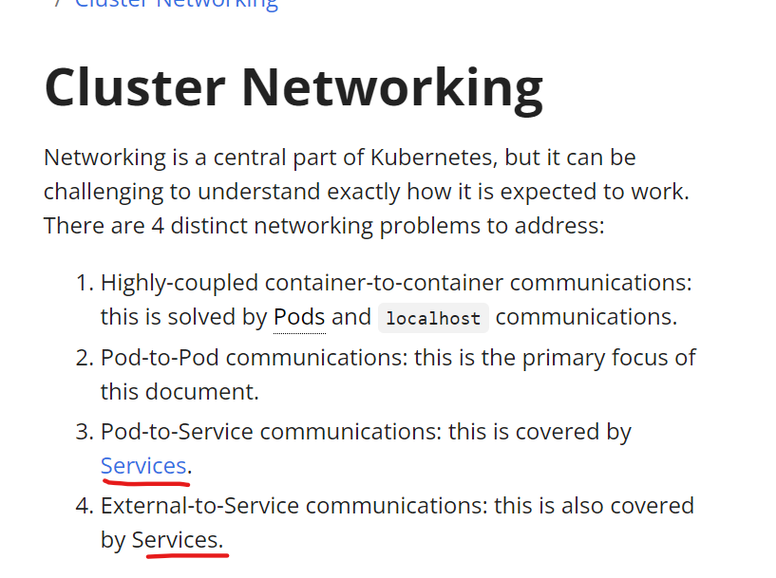

Services:

<https://home.robusta.dev/blog/kubernetes-service-vs-loadbalancer-vs-ingress>

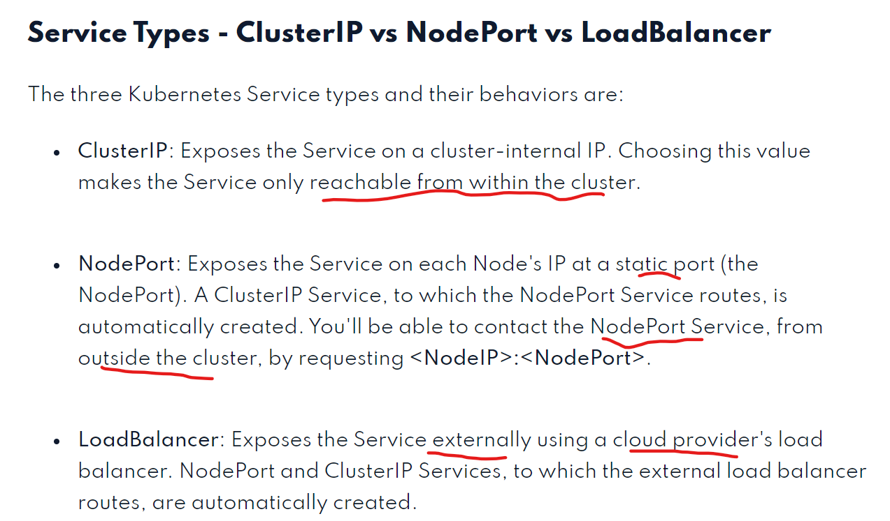

4.Headless service

<https://stackoverflow.com/questions/50891104/how-does-statefulset-and-headless-service-works-k8s>

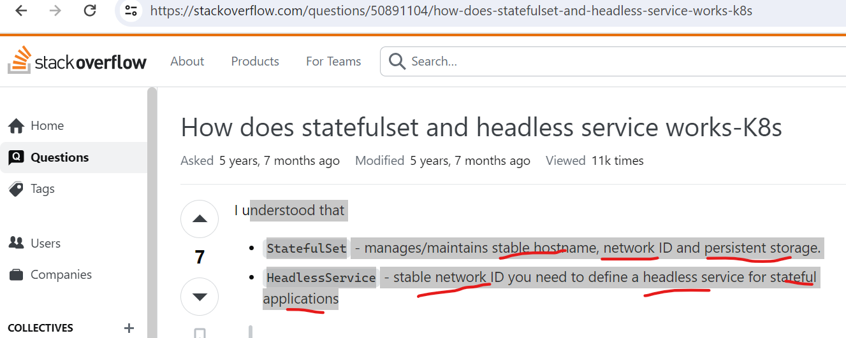

Use case

<https://medium.com/@akansh27/statefulset-3274f71a6942>

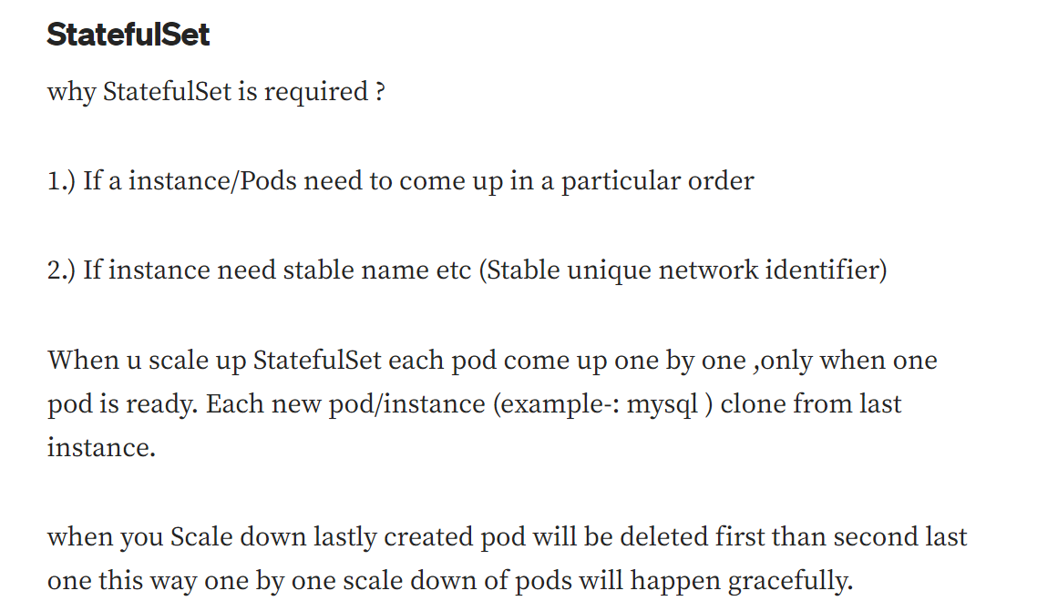

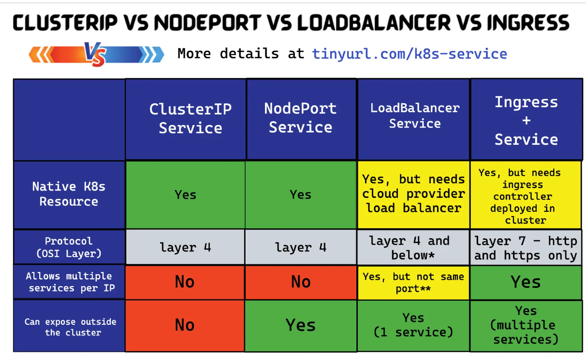

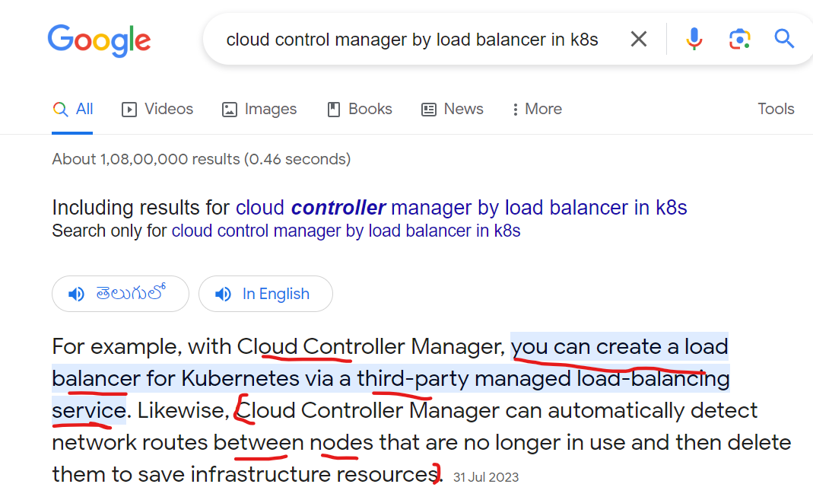

1. How will u connect to ec2 when ssh is disabled? Or what are the ways to connect to ec2 when ssh is disabled?

We cant login if u disable ssh

We got timeout error

Then enable port in 22 port inbound rule in security group and save it

Then we ca able to login

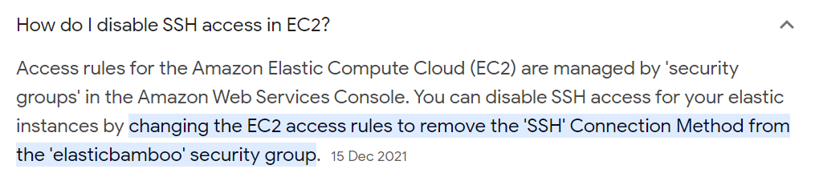

7.What is the port No for sqldb?

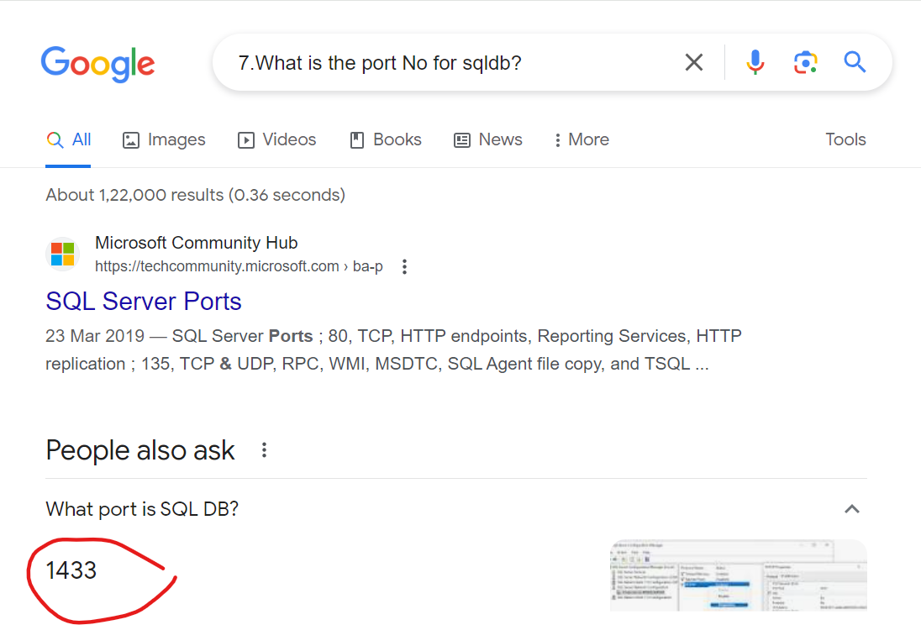

8. What is the port No for postgresdb?

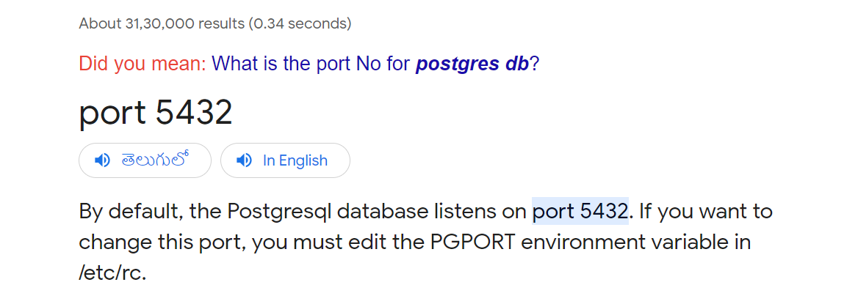

9. Tell me about the Kubernetes architecture?

<https://kubernetes.io/docs/concepts/overview/components/>

### kube-apiserver

The API server is a component of the Kubernetes [control plane](https://kubernetes.io/docs/reference/glossary/?all=true#term-control-plane) that exposes the Kubernetes API. The API server is the front end for the Kubernetes control plane.

The main implementation of a Kubernetes API server is [kube-apiserver](https://kubernetes.io/docs/reference/generated/kube-apiserver/). kube-apiserver is designed to scale horizontally—that is, it scales by deploying more instances. You can run several instances of kube-apiserver and balance traffic between those instances.

### etcd

Consistent and highly-available key value store used as Kubernetes' backing store for all cluster data.

If your Kubernetes cluster uses etcd as its backing store, make sure you have a [back up](https://kubernetes.io/docs/tasks/administer-cluster/configure-upgrade-etcd/" \l "backing-up-an-etcd-cluster) plan for the data.

### kube-scheduler

Control plane component that watches for newly created [Pods](https://kubernetes.io/docs/concepts/workloads/pods/) with no assigned [node](https://kubernetes.io/docs/concepts/architecture/nodes/), and selects a node for them to run on.

Factors taken into account for scheduling decisions include: individual and collective resource requirements, hardware/software/policy constraints, affinity and anti-affinity specifications, data locality, inter-workload interference, and deadlines

### kube-controller-manager

Control plane component that runs [controller](https://kubernetes.io/docs/concepts/architecture/controller/) processes.

Logically, each [controller](https://kubernetes.io/docs/concepts/architecture/controller/) is a separate process, but to reduce complexity, they are all compiled into a single binary and run in a single process.

There are many different types of controllers. Some examples of them are:

* Node controller: Responsible for noticing and responding when nodes go down.
* Job controller: Watches for Job objects that represent one-off tasks, then creates Pods to run those tasks to completion.
* EndpointSlice controller: Populates EndpointSlice objects (to provide a link between Services and Pods).
* ServiceAccount controller: Create default ServiceAccounts for new namespaces.

Type of controller:

* Node controller: For checking the cloud provider to determine if a node has been deleted in the cloud after it stops responding
* Route controller: For setting up routes in the underlying cloud infrastructure
* Service controller: For creating, updating and deleting cloud provider load balancers

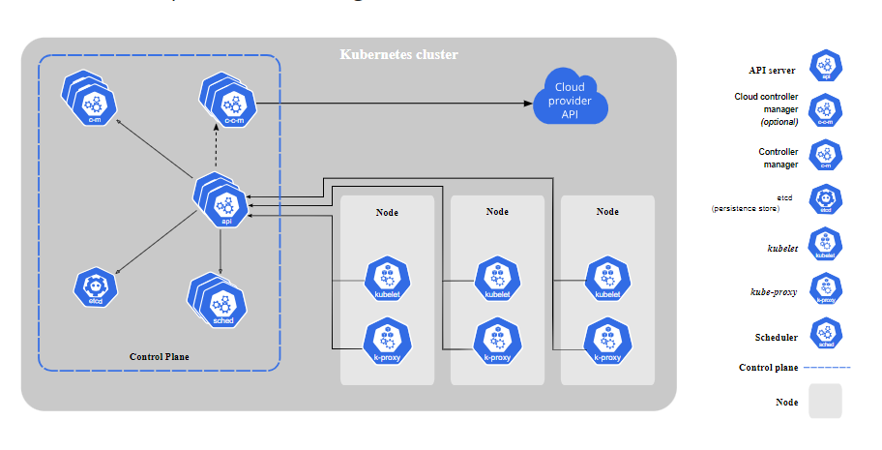

How will u expose the internet to docker application?

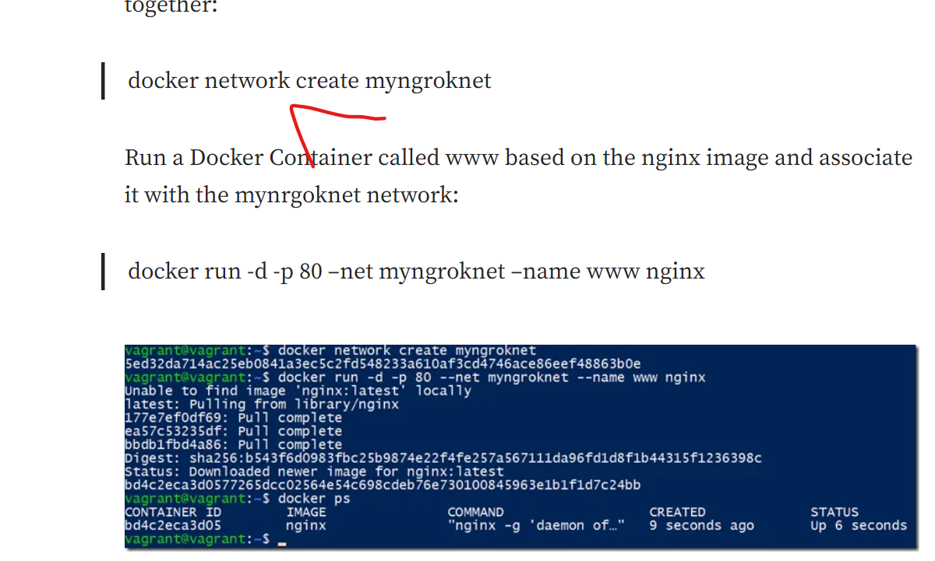

Which network driver should be used with Docker Swarm?

Overlay networks

Overlay networks are best when you need containers running on different Docker hosts to communicate, or when multiple applications work together using Swarm services.

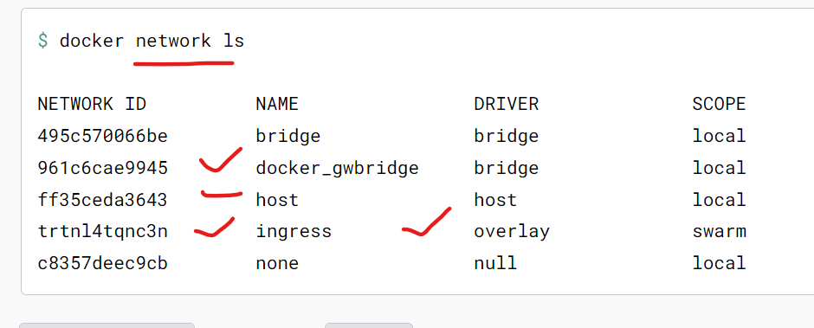

How do you handle build failures and troubleshoot issues in your build and release process?

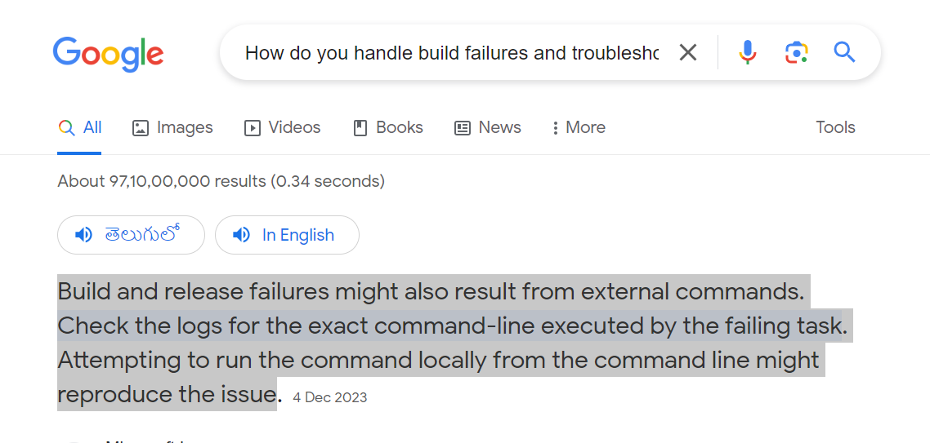

<https://learn.microsoft.com/en-us/azure/devops/pipelines/troubleshooting/troubleshooting?view=azure-devops>

<https://vercel.com/docs/deployments/troubleshoot-a-build>

.What is the command to see all running & stopped containers in docker?

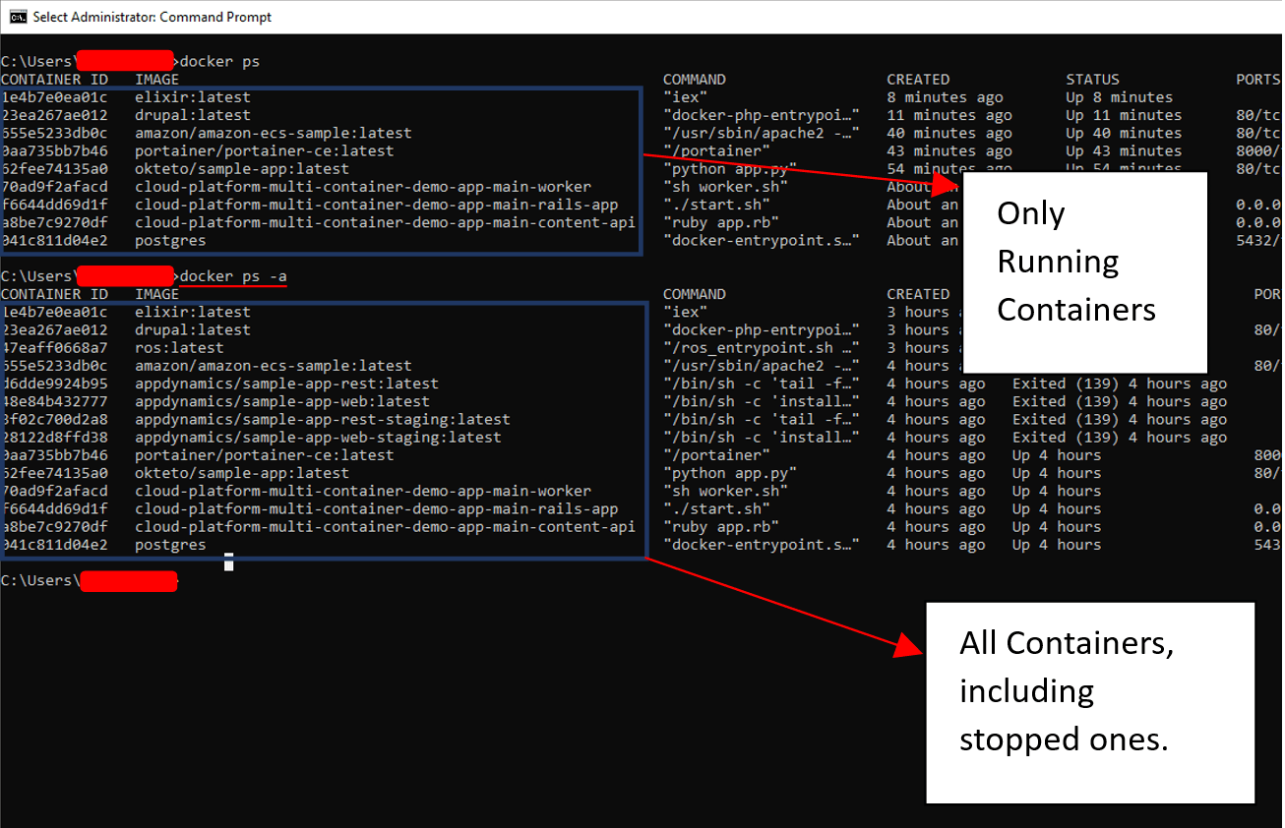

13.What is the use of systems manager in AWs?

AWS Systems Manager provides configuration management, which helps you maintain consistent configuration of your Amazon EC2 or on-premises instances. With Systems Manager, you can control configuration details such as server configurations, anti-virus definitions, firewall settings, and more.